# Optimizing User, Group, and Role Management with Access Control and Workflows

Team ID : NM2025TMID17550

Team Size : 4

Team Leader : Hashwand.V

Team member : Pradeep.N

Team member : Gopi.R

Team member : Gowthamaraj.N

# Problem Statement:

In a small project management team consisting of a Project Manager (Alice) and a Team Member (Bob), there is a need to efficiently manage project tasks and ensure accountability throughout the project lifecycle. The current system lacks clear role definitions, access controls, and a structured workflow, leading to confusion regarding task assignments and progress tracking.

Objectives:  
The project aims to optimize user, group, and role management by establishing a secure and scalable access control framework integrated with automated workflows. It seeks to simplify the administration of user accounts, streamline group assignments, and enforce role-based access policies to minimize security risks. By implementing centralized controls and approval-driven workflows, the system ensures that access rights are granted appropriately, updated efficiently, and revoked promptly when necessary. Ultimately, the objective is to enhance operational efficiency, strengthen data security, and provide organizations with greater visibility and governance over user access across systems and applications.

# Skills:

1. Oracle DB

# TASK INITIATION:

Milestone 1

**Create Users**

* 1. Open service now
  2. Click on All  >> search for users
  3. Select Users under system security
  4. Click on new
  5. Fill the following details to create a new user
  6. Click on submit

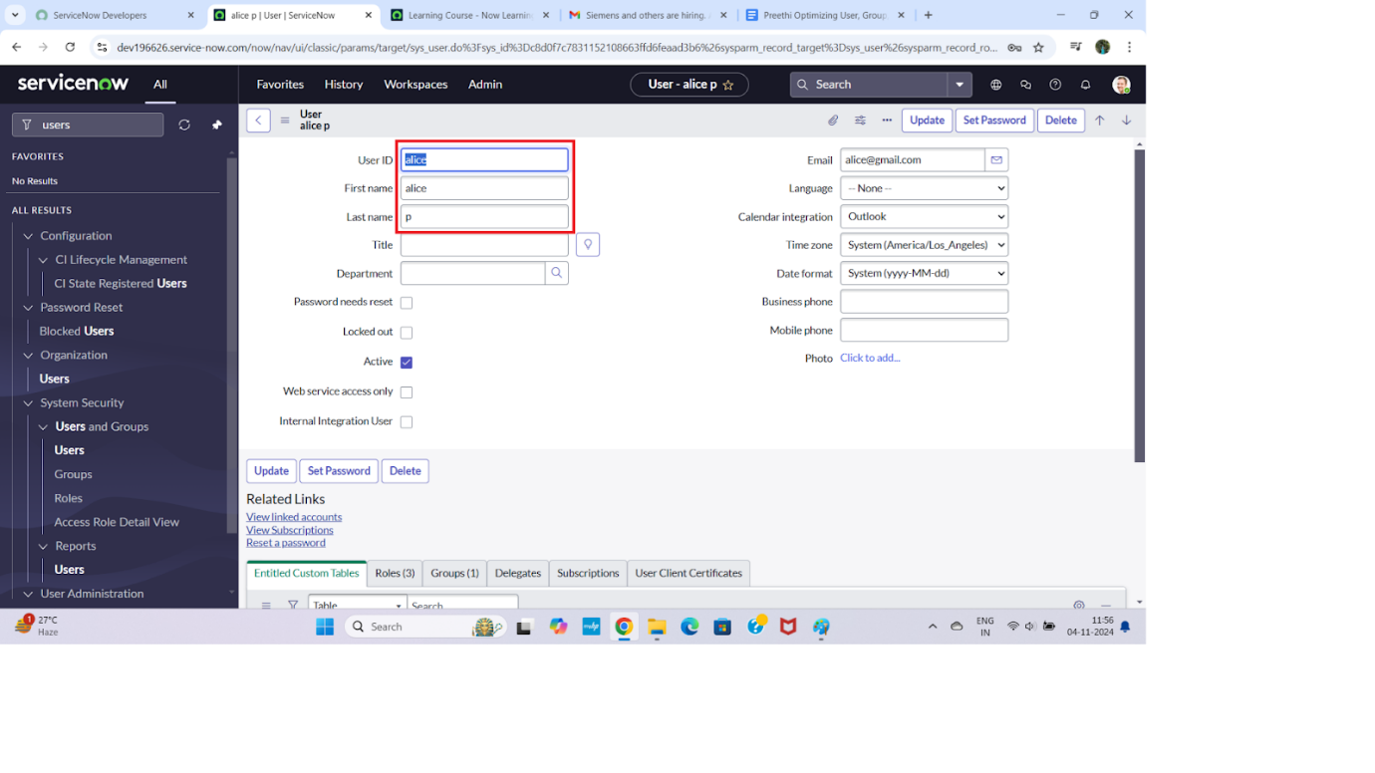

**Create one more user:**

* 1. Create another user with the following details
  2. Click on submit

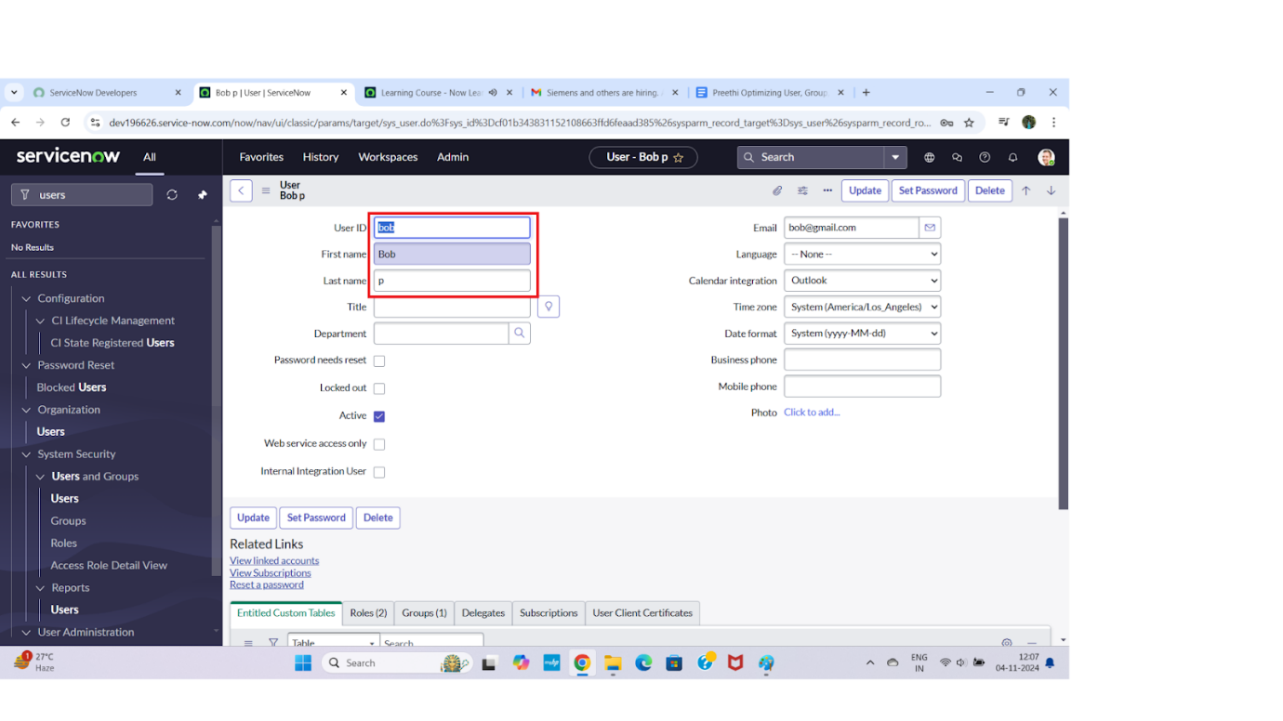

Milestone 2

**Create Groups**

1. Open service now.
2. Click on All  >> search for groups
3. Select groups under system security
4. Click on new
5. Fill the following details to create a new group
6. Click on submit

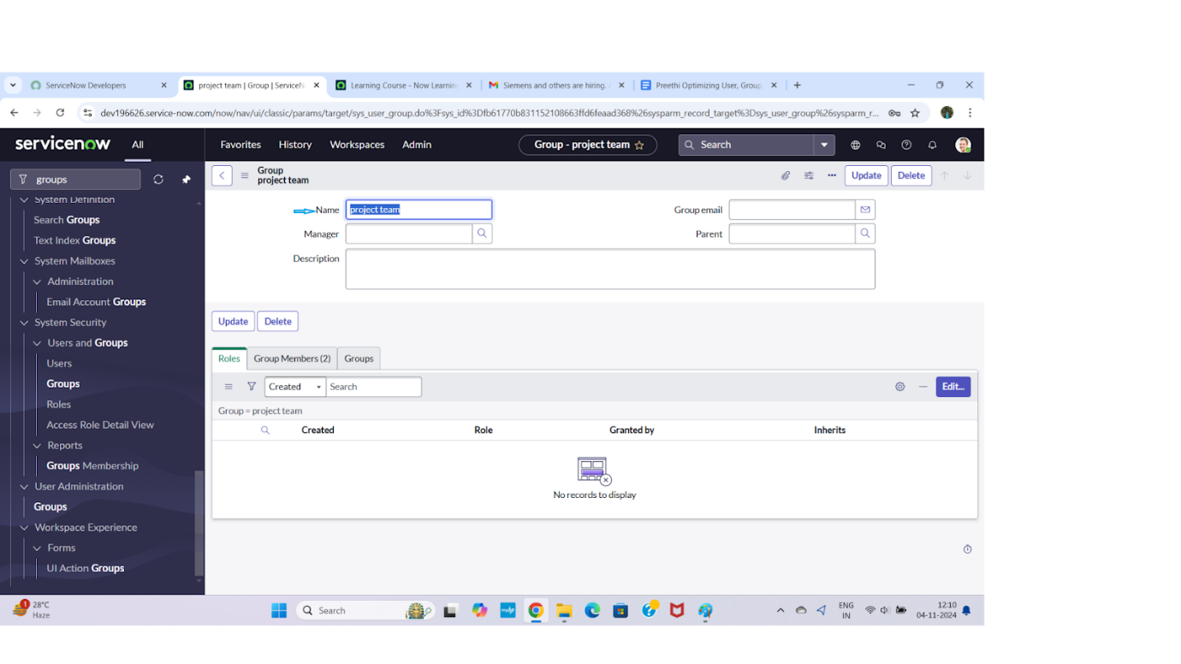

Milestone 3

**Create Roles**

1. Open service now.
2. Click on All  >> search for roles
3. Select roles under system security
4. Click on new
5. Fill the following details to create a new role
6. Click on submit

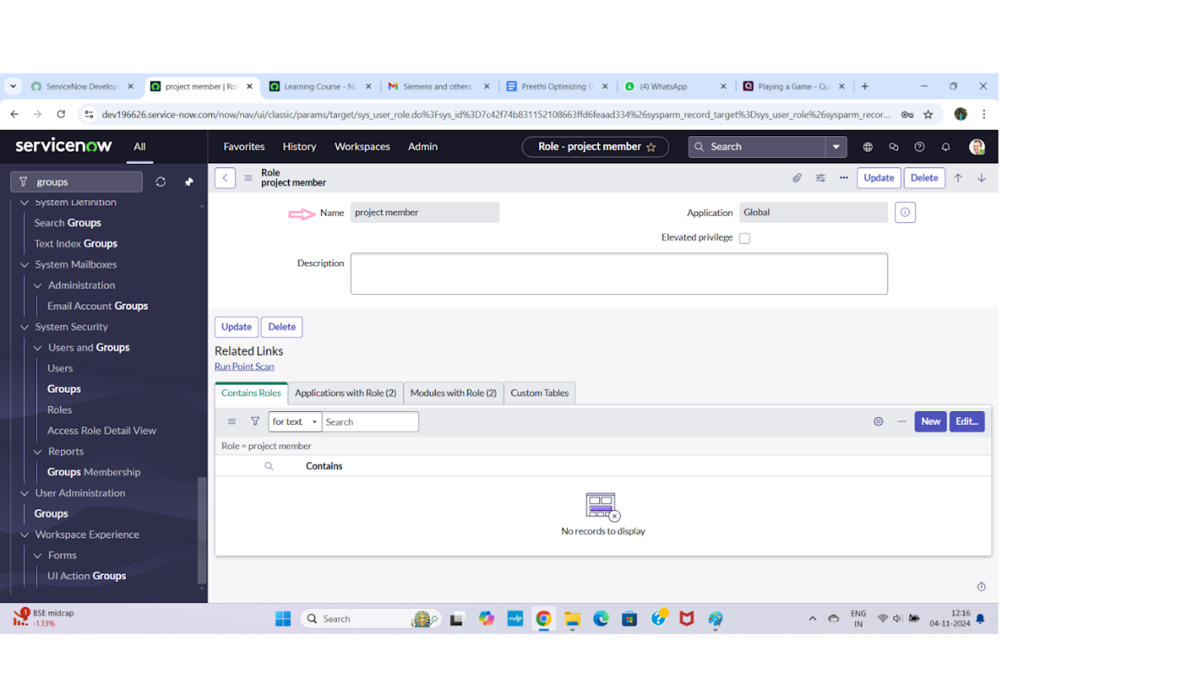

**Create one more role:**

             7.Create another role with the following details : Team member

             8.Click on submit

Milestone 4

**Create Table**

* 1. Open service now.
  2. Click on All  >> search for tables
  3. Select tables under system definition
  4. Click on new
  5. Fill the following details to create a new table  
     Label : project table  
     Check the boxes Create module & Create mobile module
  6. Under new menu name : project table
  7. Under table columns give the columns

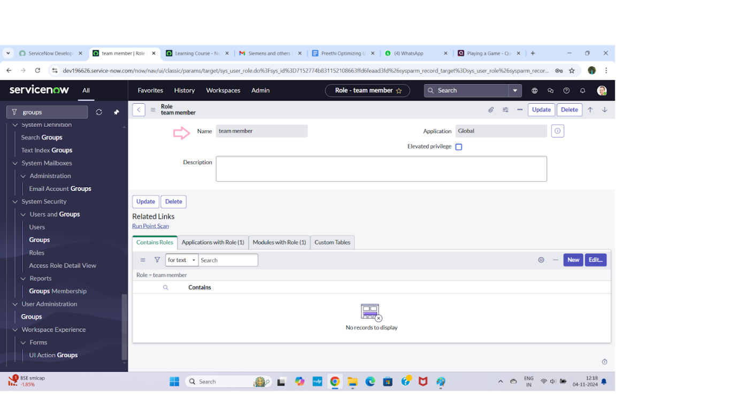

* 1. Click on submit

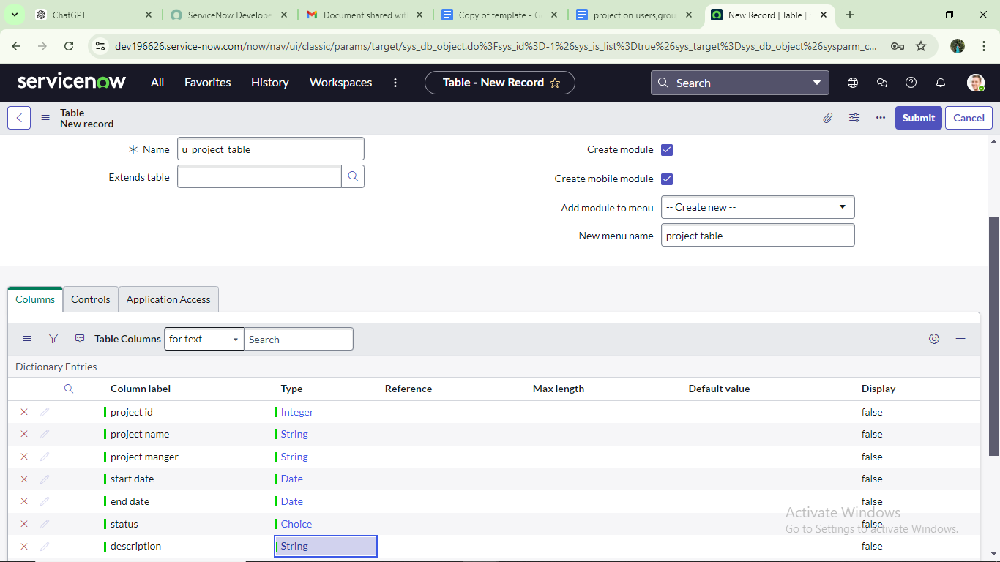

**Create one more table:**

   9.Create another table as: task table 2 and fill with following details.

   10. Click on submit.

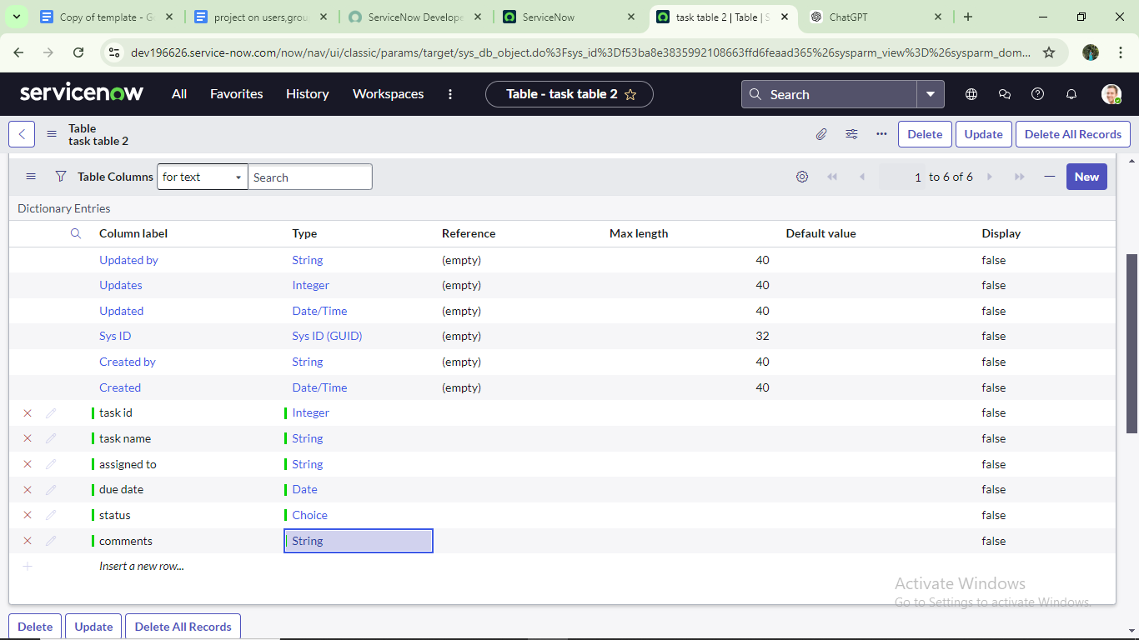

Milestone 5

**Assign users to project team group**

1. 1.Open service now.

2.Click on All  >> search for groups

3.Select tables under system definition

4.Select the project team group

5.Under group members

6.Click on edit

7.Select  alice p and bob p and save

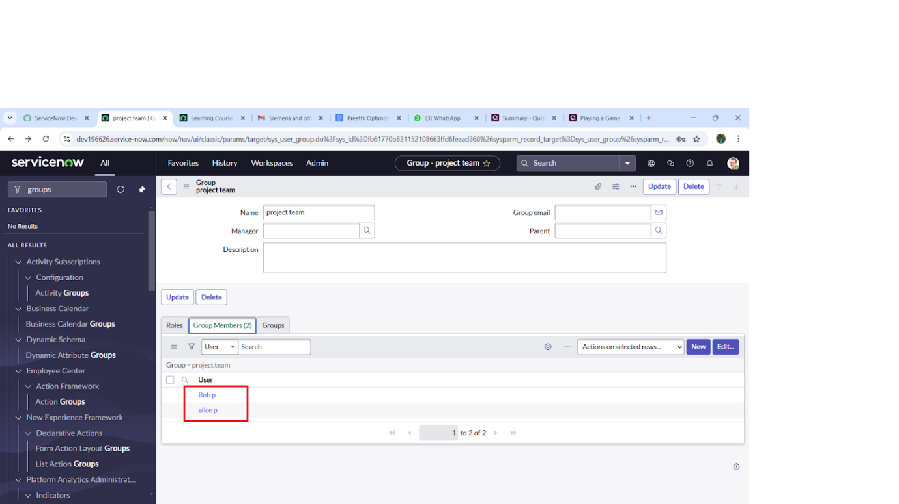

Milestone 6

**Assign roles to alice user**

1. 1.Open servicenow.Click on All  >> search for user

      2.Select tables under system definition

      3.Select the project manager user

      4.Under project manager

      5.Click on edit

      6.Select project member and save

      7.click on edit add u_project_table role and u_task_table role

      8.click on save and  update the form.

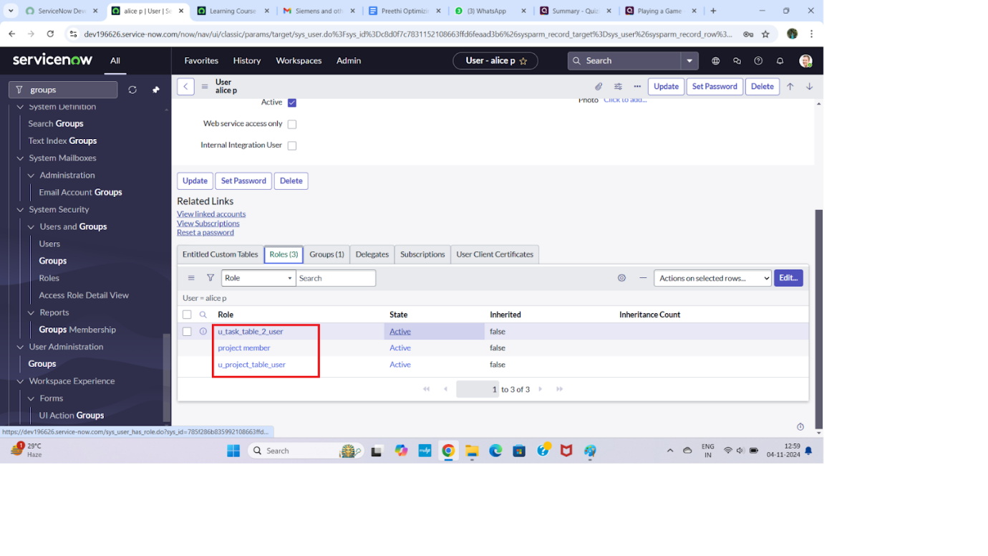

**Assign roles to bob user**

 1. Open ServiceNow. Click on All  >> search for user

      2.Select tables under system definition

      3.Select the bob p user

      4.Under team member

      5.Click on edit

      6.Select team member and give table role  and save

      7. Click on profile icon Impersonate user to bob

      8. We can see the task table2.

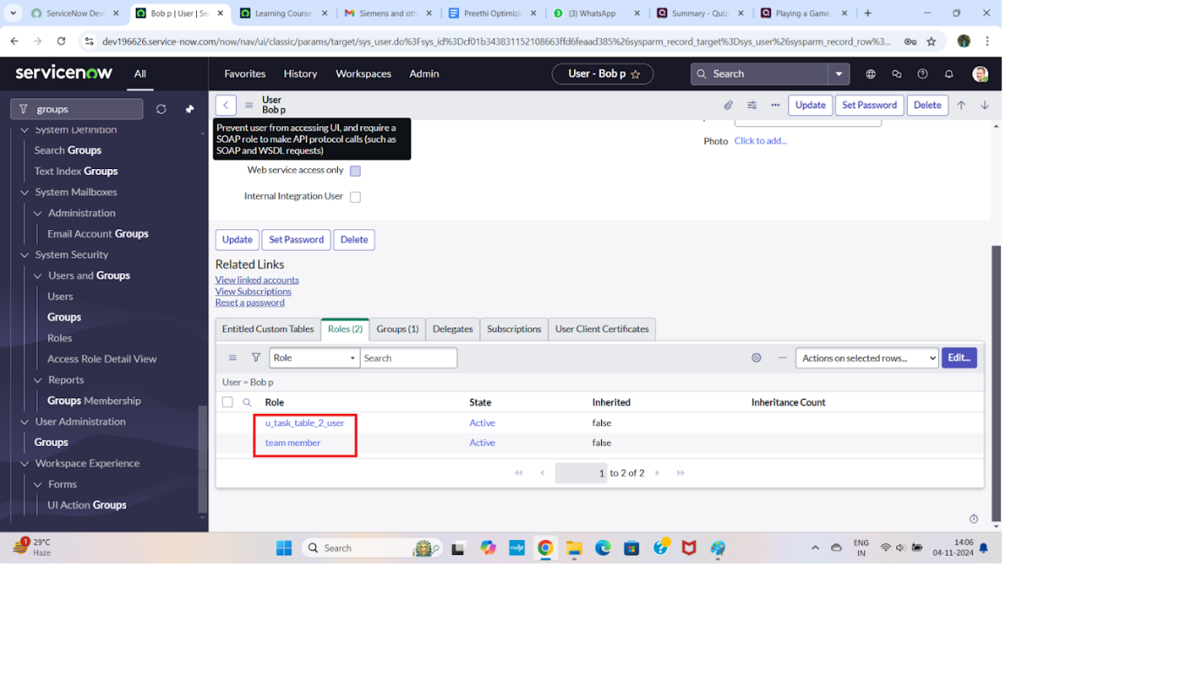

Milestone 7

Assign table access to application

 while creating a table it automatically create a application and module for that table

Go to application navigator search for search project table application

Click on edit module

Give project member  roles to that application

Search for task table2 and click on edit application.

Give the project member and team member role for task table 2 application

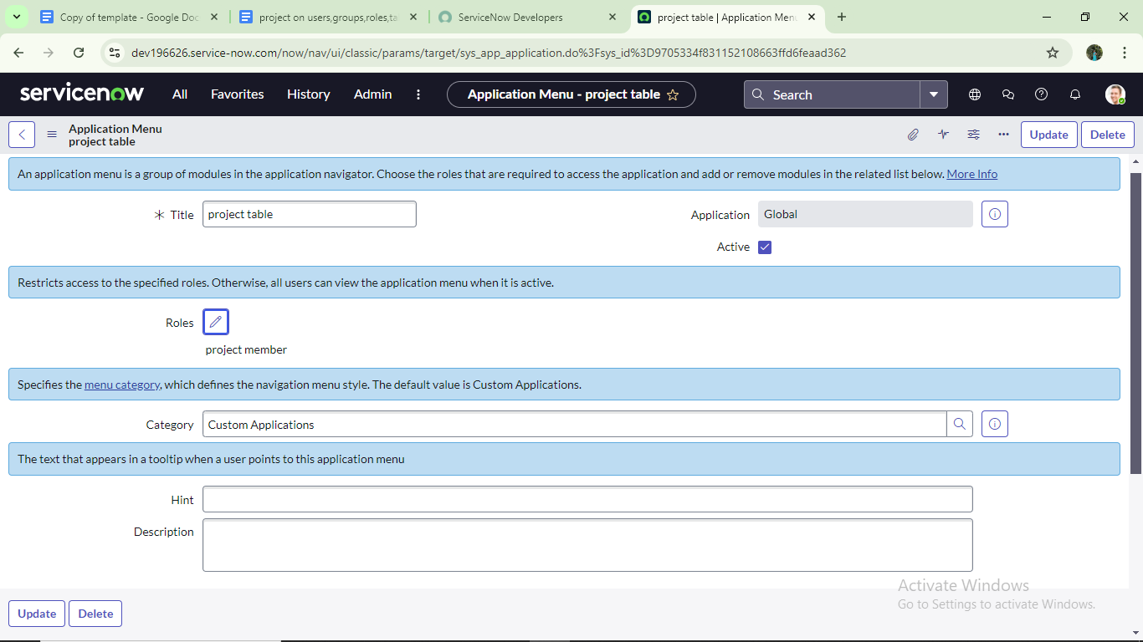

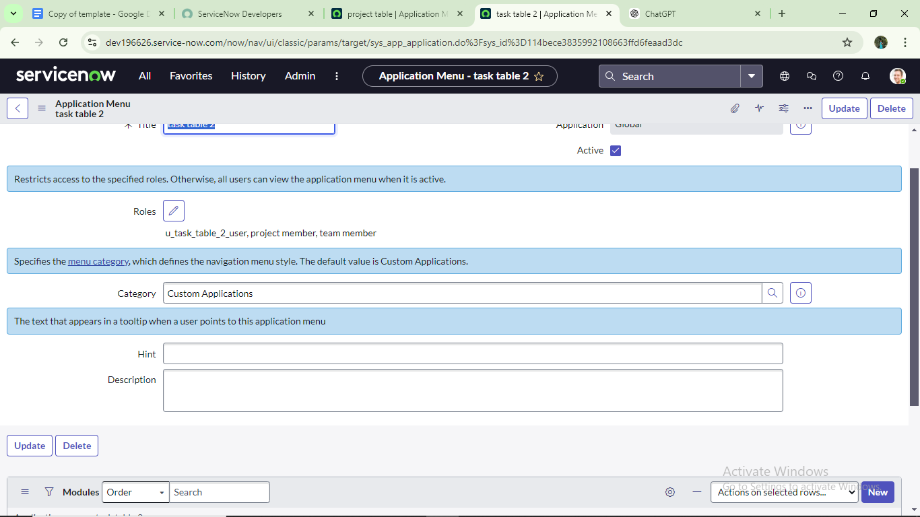

Milestone 8

# Create ACL

# Open service now.

# Click on All  >> search for ACL

# Select Access Control(ACL) under system security

# Click on elevate role

# Click on new

# Fill the following details to create a new ACL

Scroll down under requires role

Double click on insert a new row

Give task table and team member role

Click on submit

# Similarly create 4 acl for the following fields

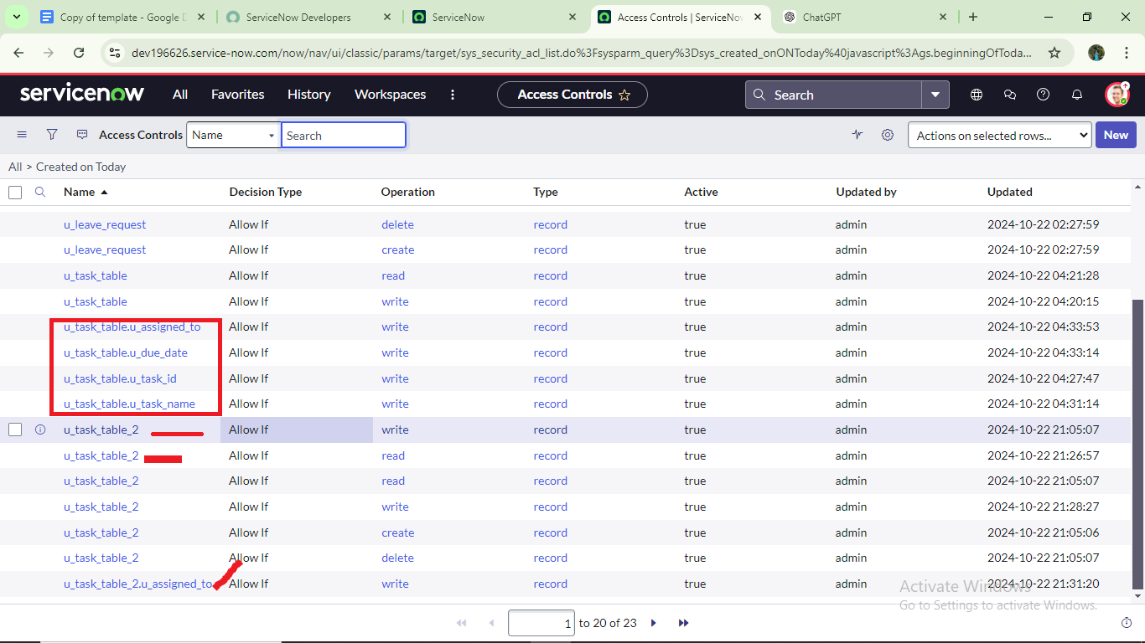

      12.Click on profile on top right side

      13.Click on impersonate user

      14.Select  bob user

      15.Go to all and select task table2 in the application menu bar

      16. Comment and status fields are have the edit access

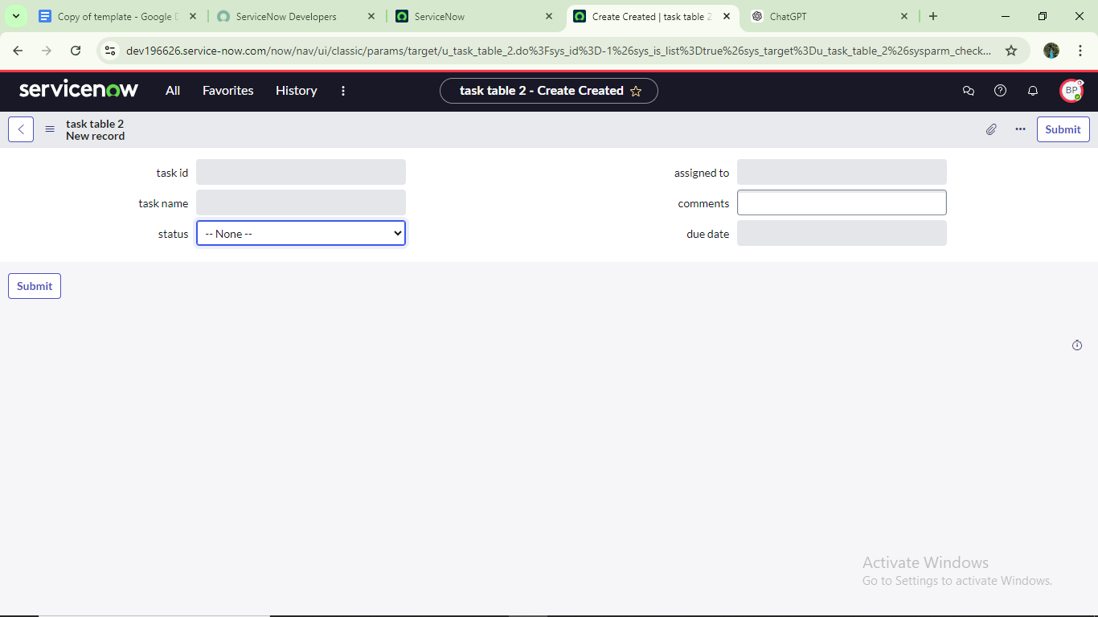

Milestone 9

Create a Flow to Assign operations ticket to group

Open service now.

Click on All  >> search for Flow Designer

Click on Flow Designer under Process Automation.

After opening Flow Designer Click on new and select Flow.

Under Flow properties Give Flow Name as “ task table”.

Application should be Global.

Click build flow.

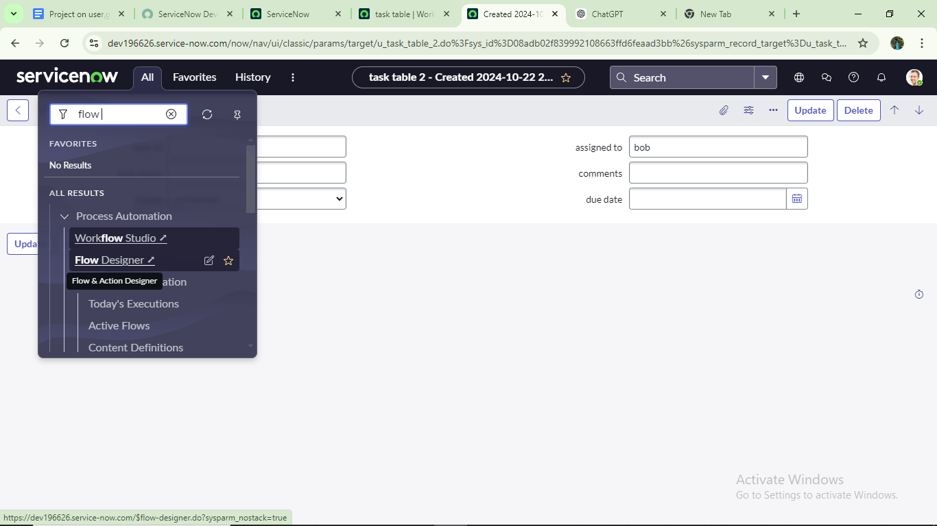

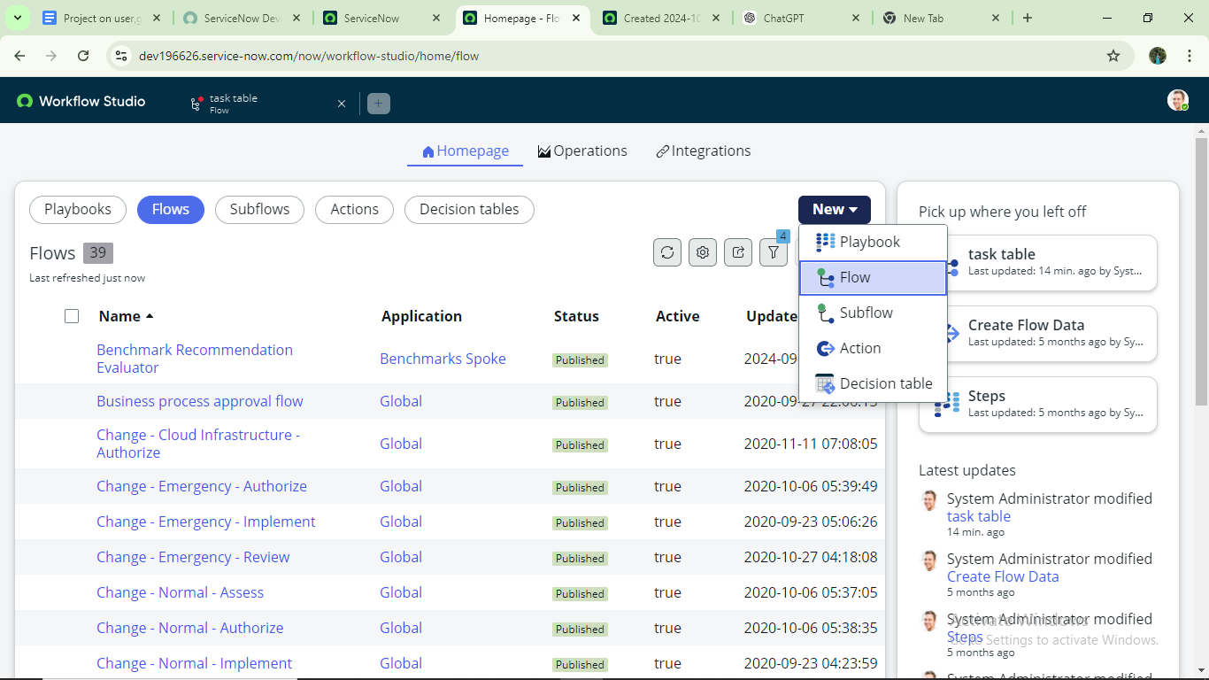

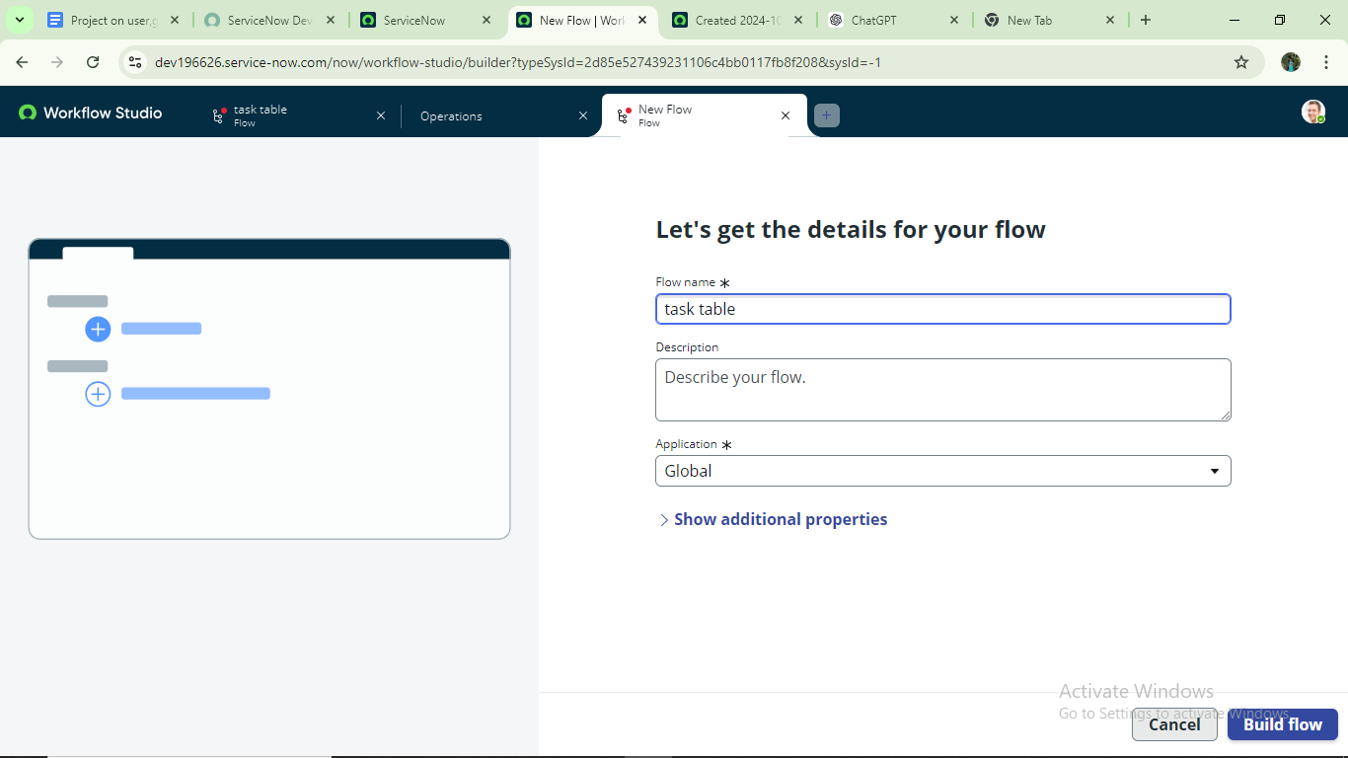

next step:

Click on Add a trigger

Select the trigger in that Search for “create  record”  and select that.

Give the table name as “ task table ”.

Give the Condition as Field : status Operator :is Value : in progress

                                   Field : comments Operator :is Value : feedback

                                   Field : assigned to Operator :is Value : bob

After that click on Done.

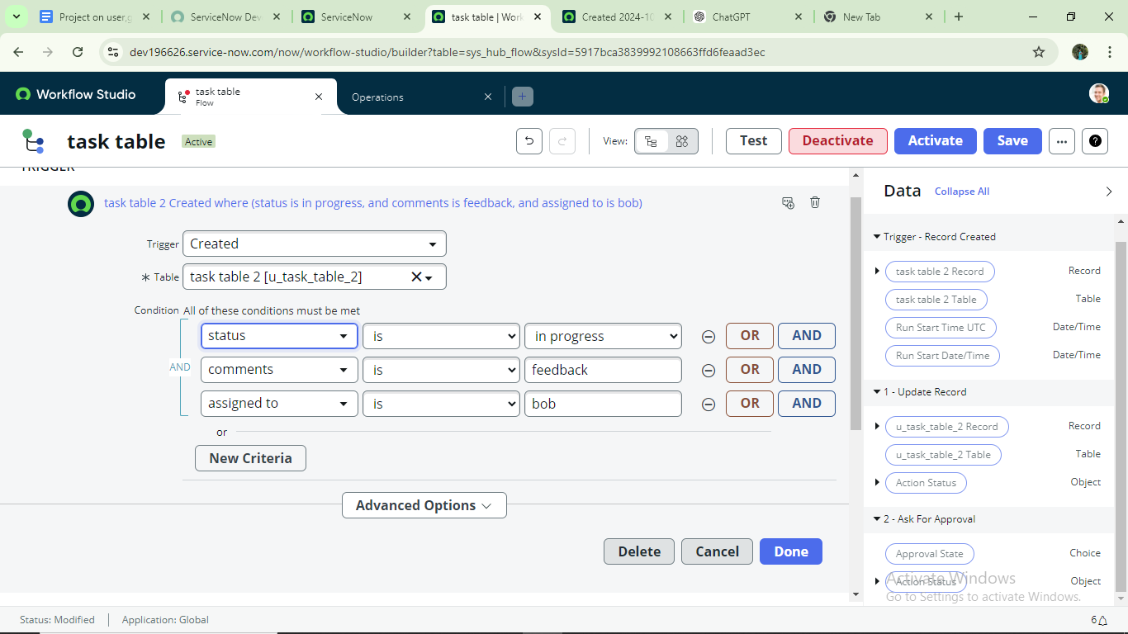

Next step:

Click on Add an action.

Select action in that ,search for “ update records”.

In Record field drag the fields from the data navigation from Right Side(Data pill)

Table will be auto assigned after that

Add fields as “status” and value as “completed”

Click on Done.

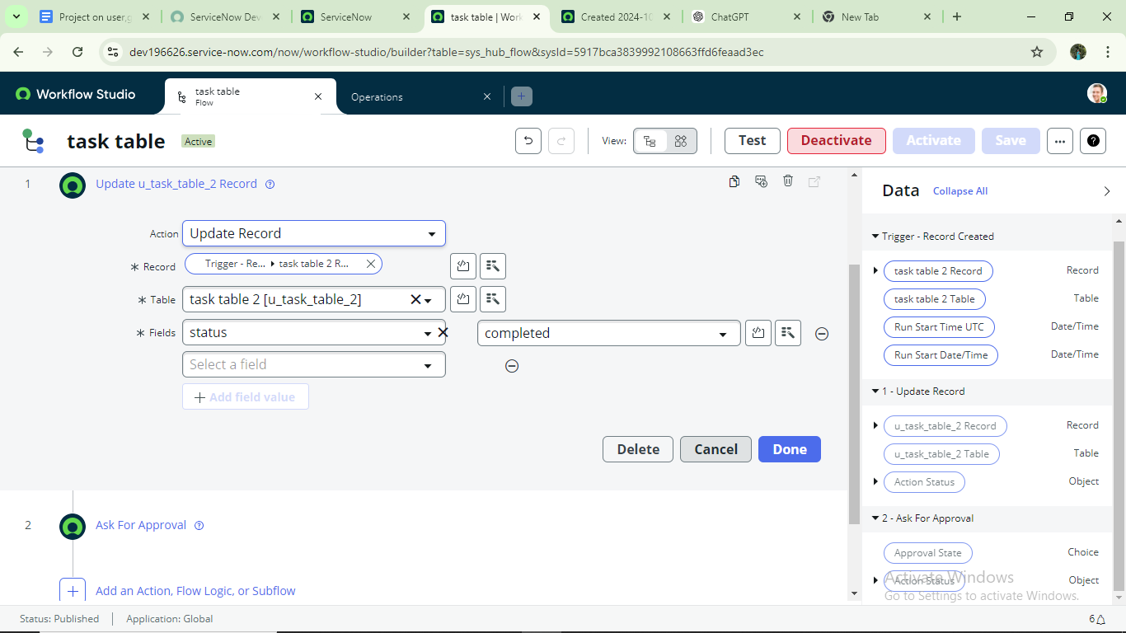

Next step:

Now under Actions.

Click on Add an action.

Select action in that ,search for “  ask for approval ”.

In Record field drag the fields from the data navigation from Right side

Table will be auto assigned after that

Give the approve  field as “ status”

Give approver as alice p

Click on Done.

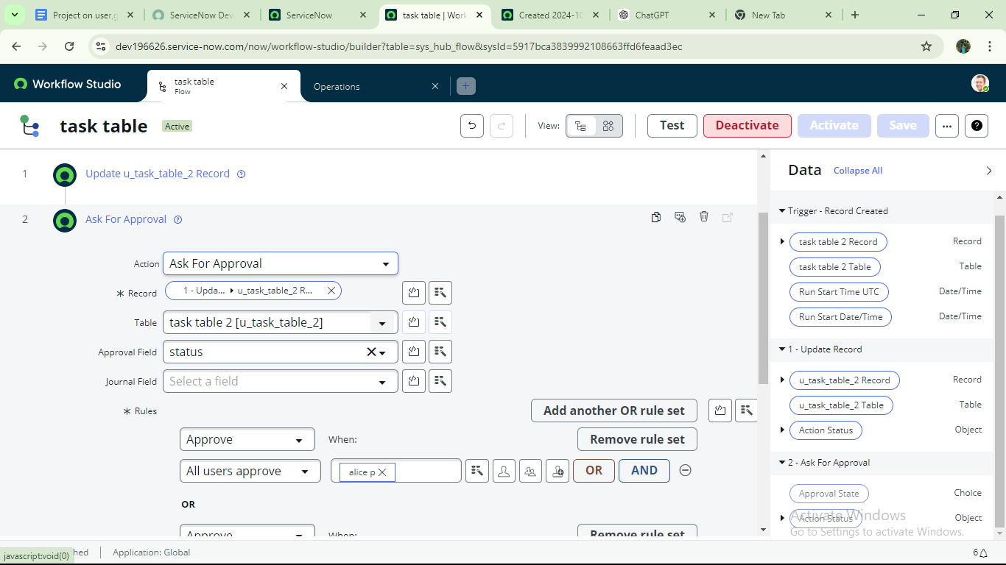

9.Go to application navigator search for task table.

10.It status field is updated to completed

# Conclusion

This scenario highlights a structured approach to project management, showcasing the roles of Alice and Bob within a defined workflow. With Alice's oversight and Bob's execution, the team effectively collaborates to ensure project success. The use of tables organizes key information, facilitating easy tracking of projects, tasks, and progress updates. Overall, this system promotes accountability, enhances communication, and leads to the successful completion of projects.

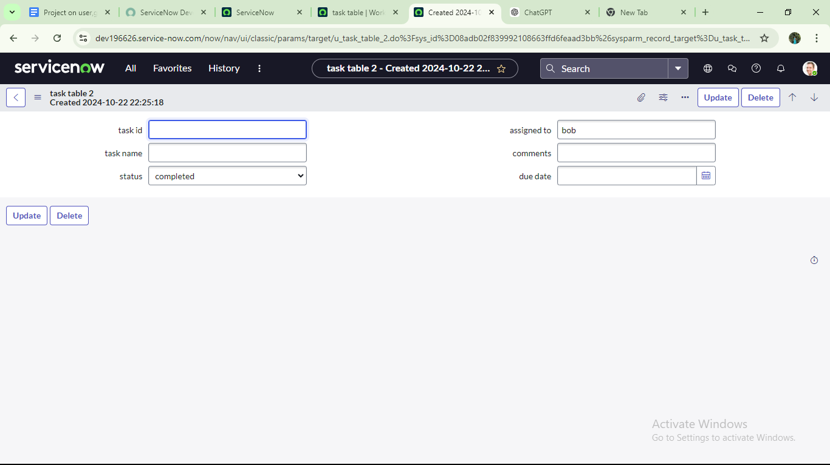

11.Go to application navigator and search for my approval

12.Click on my approval under the service desk.

13. Alice p got approval request then right click on requested then select approved



 